**⭐ 1. Offline Pipeline (Local Development Workflow) (just the modeling part)**

Based on the structure of your project, your local workflow already follows a standard ML pipeline:

**1️。Data Collection (0-data)**

* **make-dataset-stocks.py:** Fetches stock prices, volumes, and technical data from Yahoo Finance.
* **make-dataset-news.py:** Fetches news articles and raw sentiment scores from Alpha Vantage.

**Output:**Raw datasets saved under data/raw/

* stocks.csv
* news.csv

collect the data from 2023-01-01 to 2025-12-09

news from alpha vantage

stocks from the yfinance

tickers = ["AAPL", "GOOG"]

start_date = "2023-01-01"

end_date = "2025-12-09"

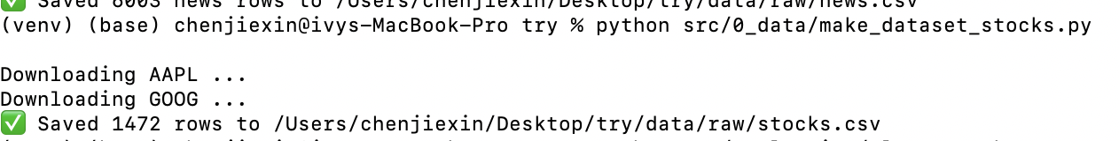

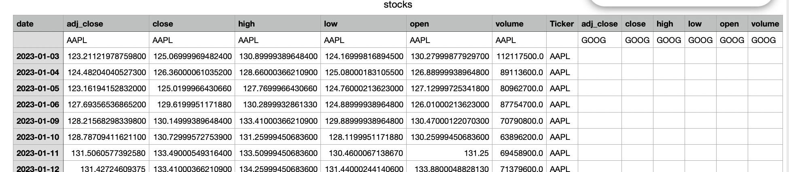

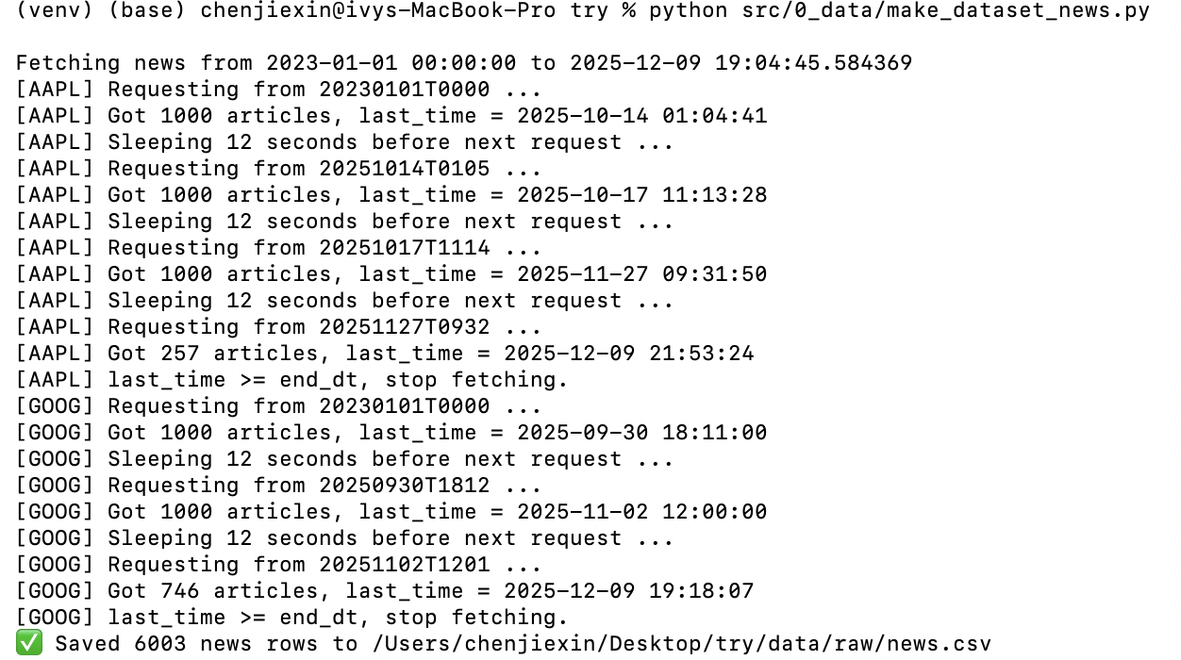

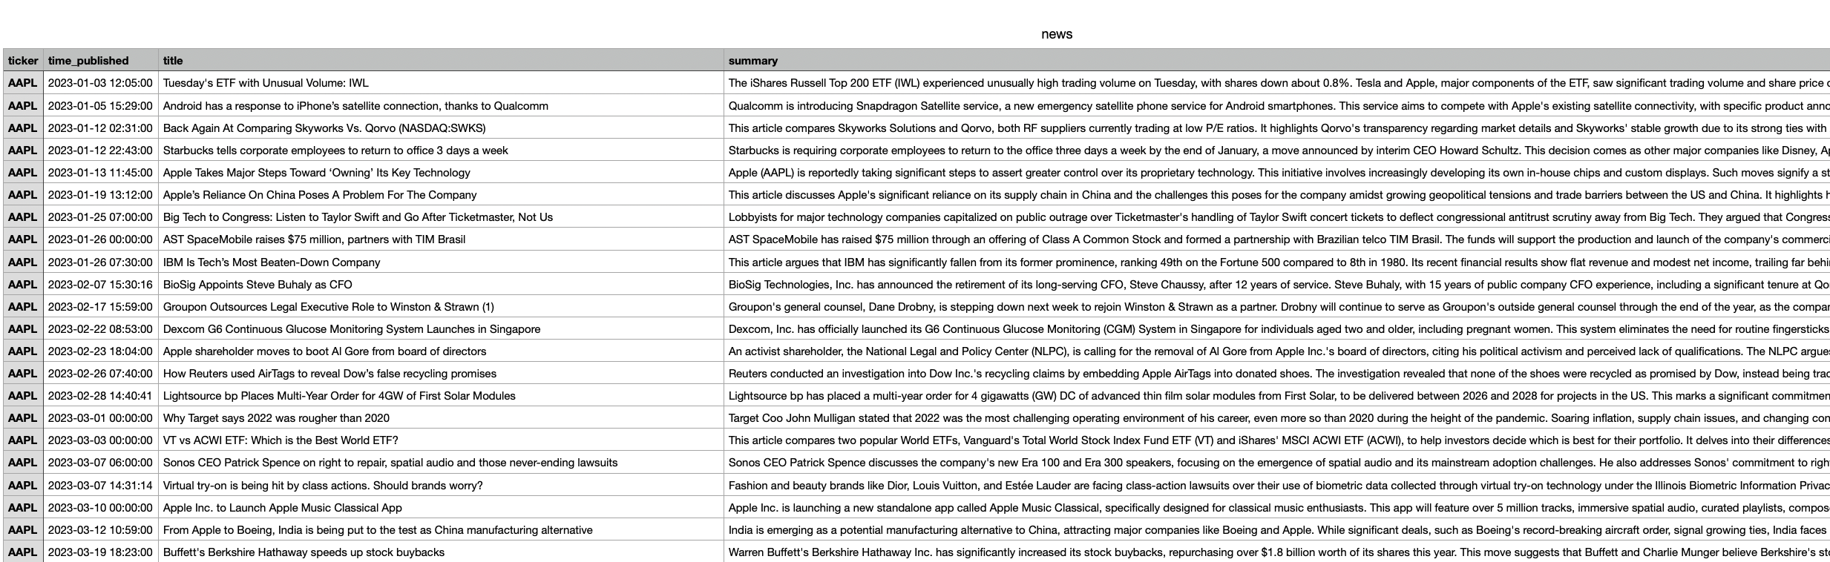

**2️。Data Cleaning (1-cleaning)**

* **clean-stocks.py:** Handles missing values, removes anomalies, unifies timestamps.
* **clean-news.py:** Cleans news text and removes invalid records.

**Output:**Clean datasets saved under data/clean/

* clean_stocks.csv

• Load raw Yahoo Finance data with multi-level headers.

• Reshape into long format (date, ticker, open, high, low, close, adj_close, volume).

• Remove duplicates and sort by date.

• Save cleaned file to data/clean/stocks_clean.csv.

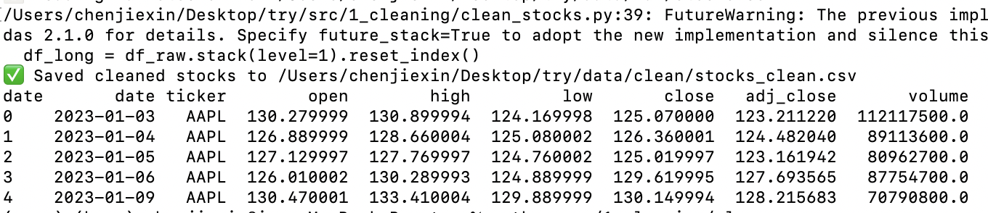

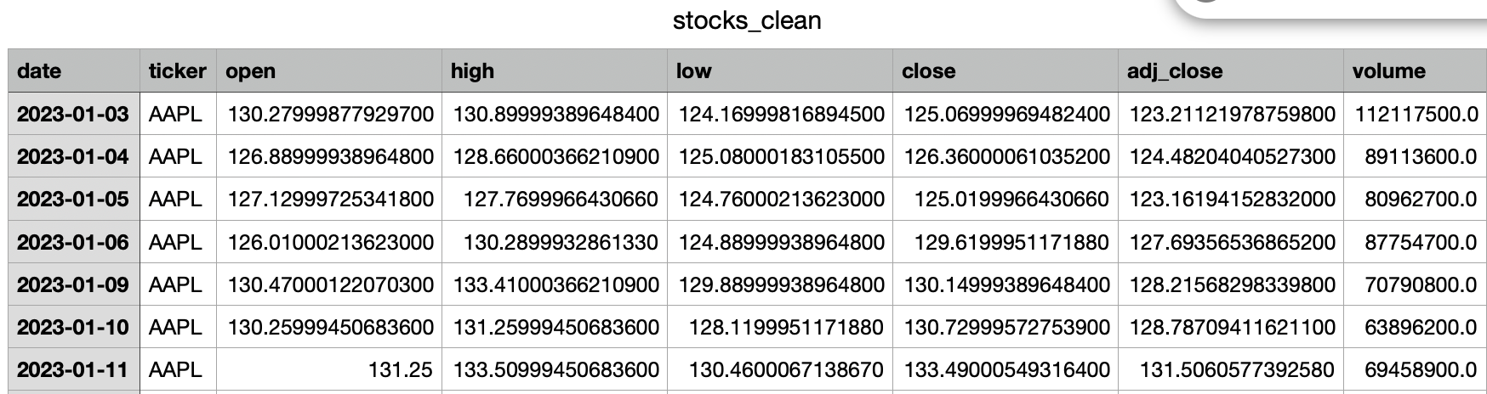

* clean_news.csv
* Load raw Alpha Vantage news data.
* Parse time_published and extract a daily date.
* Drop incomplete rows.
* Save cleaned file to data/clean/news_clean.csv.

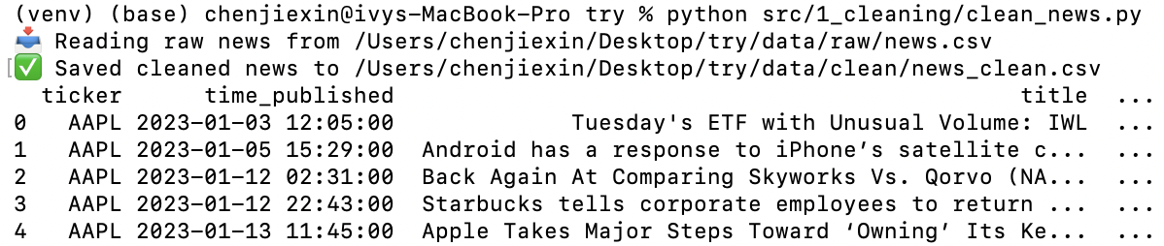

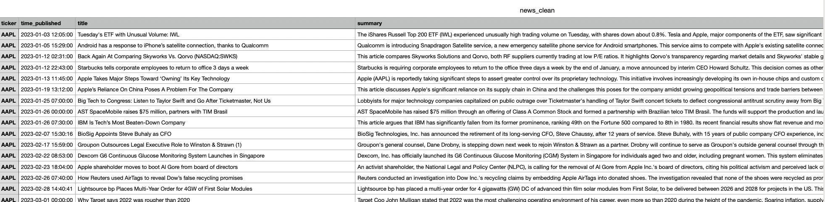

**3️。Feature Engineering**

* **build-stock-features.py:** Creates price-based features (lags, rolling statistics, technical indicators).
* **build-news-features.py:** Runs FinBERT sentiment analysis to generate sentiment scores.

**Output:**Aligned and merged feature datasets stored under data/features/

* **Price-only features**
* **Price + Sentiment features**

These are stored as .csv files for training.

**build-stock-features.py**

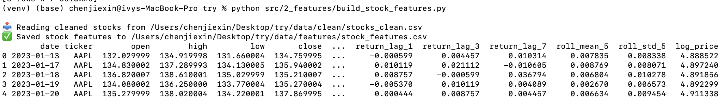

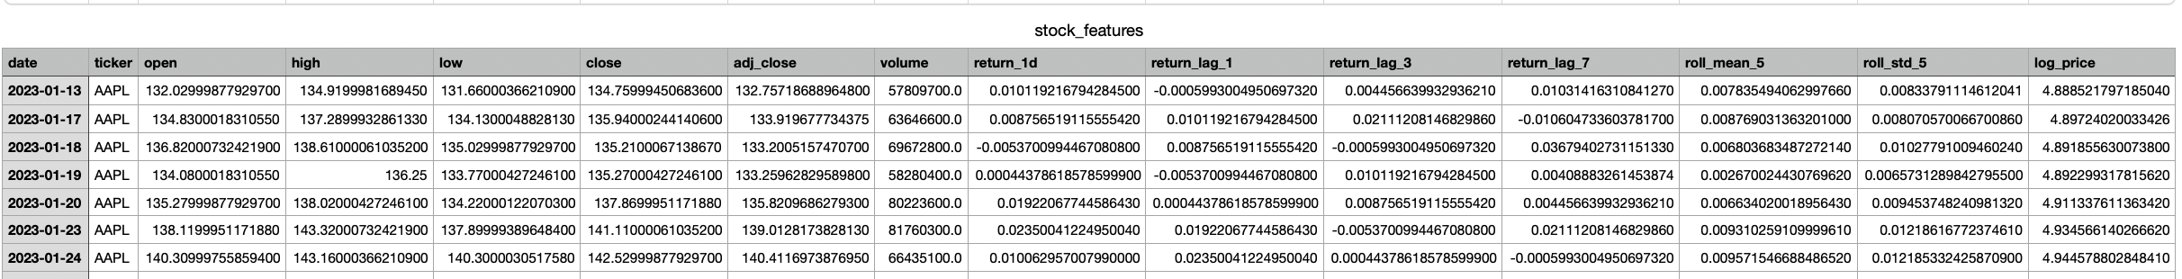

**build-news-features.py**

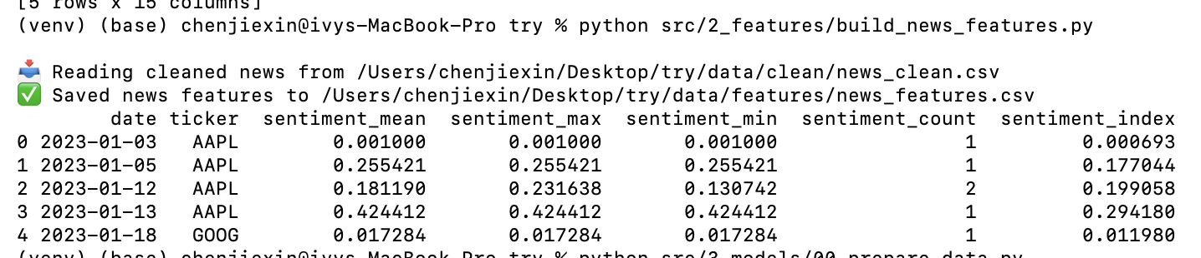

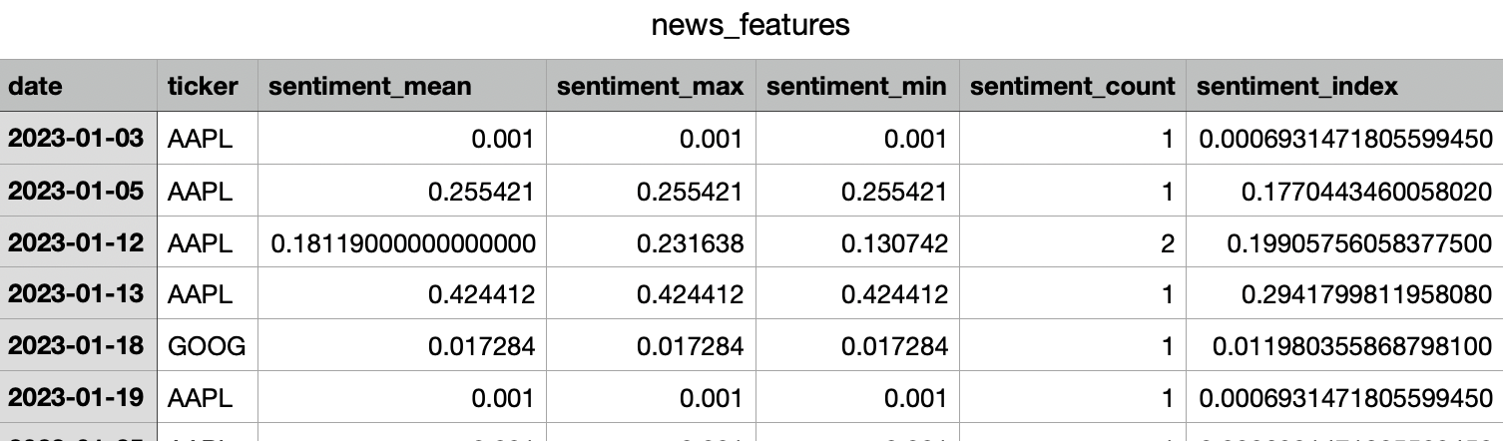

**4️。Modeling & Evaluation**

**00_prepare_data.py**

**Purpose:  
Merge the cleaned stock and news datasets, align timestamps across tickers, generate engineered features (returns, lags, rolling statistics, sentiment alignment), and split the final dataset into train/val/test sets for all downstream models.  
This script provides the standardized input data used by both baseline and deep learning models.**

**00_baseline_moving_average.py**

**Purpose:  
Compute simple Moving Average (MA7 and MA14) forecasts as rule-based baselines.  
These models require no training and provide a minimal benchmark to evaluate whether more advanced models deliver meaningful improvements.**

**00_baseline_xgboost.py**

**Purpose:  
Train an XGBoost regressor using hand-crafted price-related features (lags, rolling mean/volatility).  
This baseline represents a classical machine learning approach and serves as a bridge between naive baselines (MA) and deep learning models.**



**📌 Price-Only Deep Learning Models**

**These models test the predictive power of pure price information, without sentiment.**

**01_lstm_price_only.py**

**Purpose:  
Train an LSTM model using only historical price and technical features.  
This serves as the foundational deep learning baseline for sequence modeling of stock price movements.**

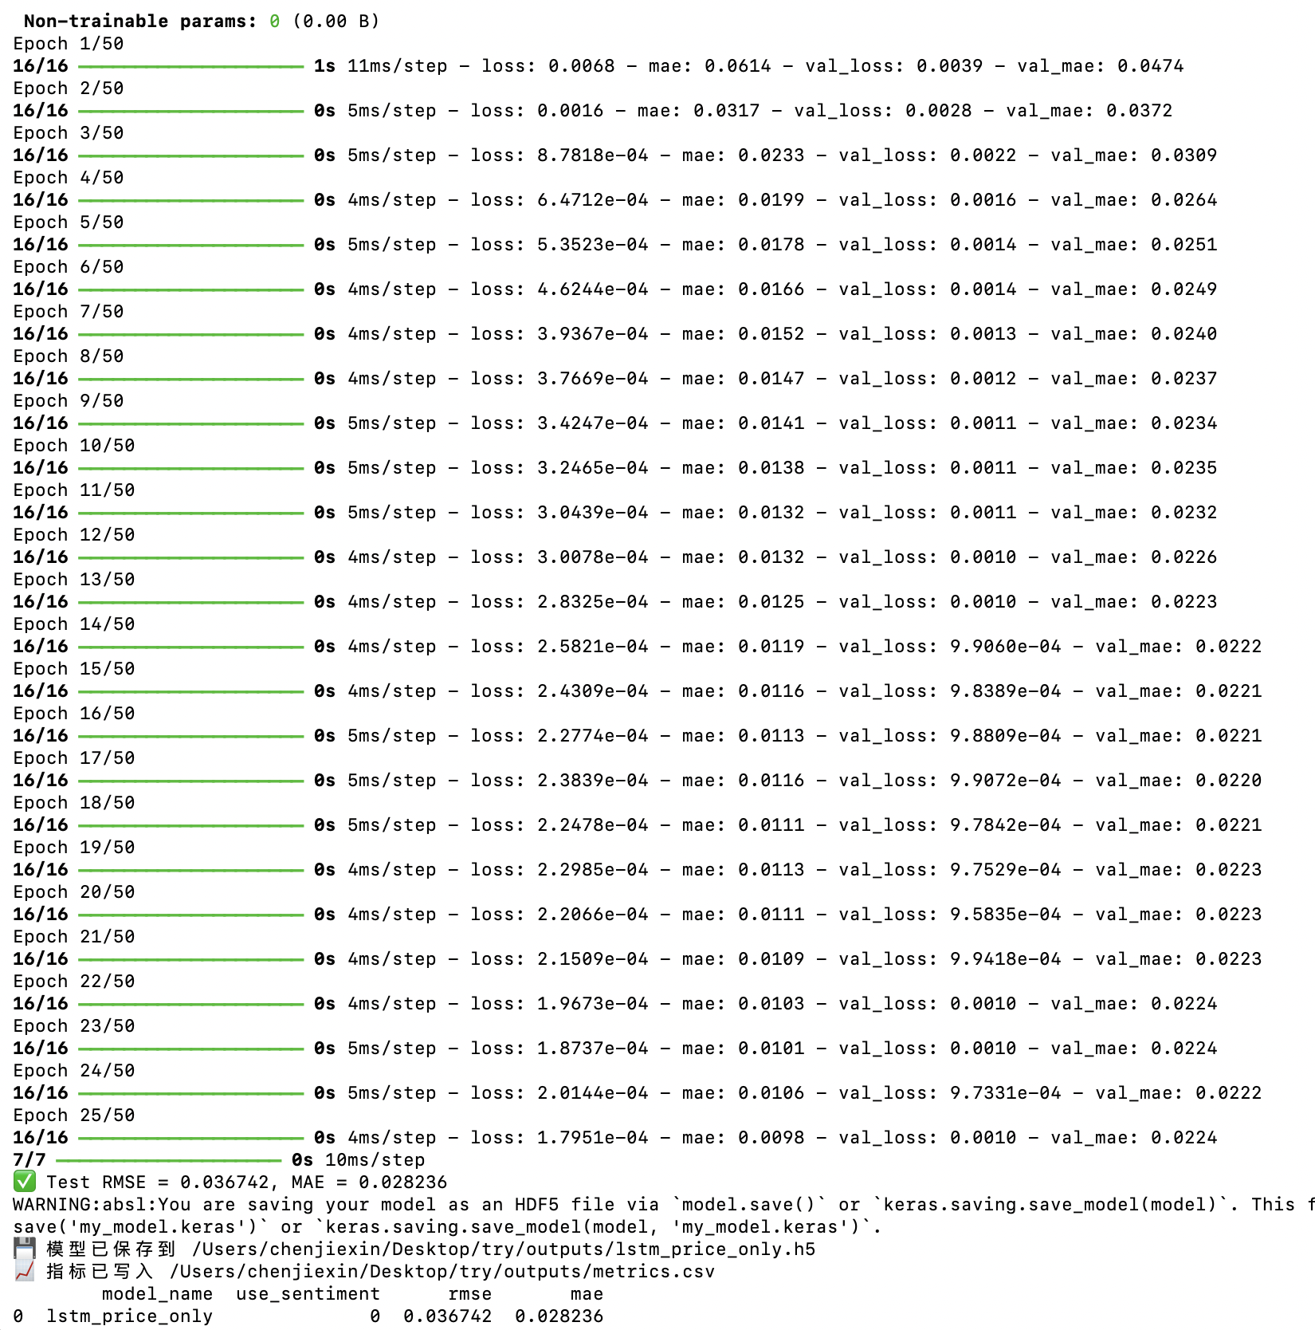

**02_gru_price_only.py**

**Purpose:  
Train a GRU-based model using the same price-only features.  
GRUs are a lighter alternative to LSTMs and provide a comparison of recurrent architectures.**

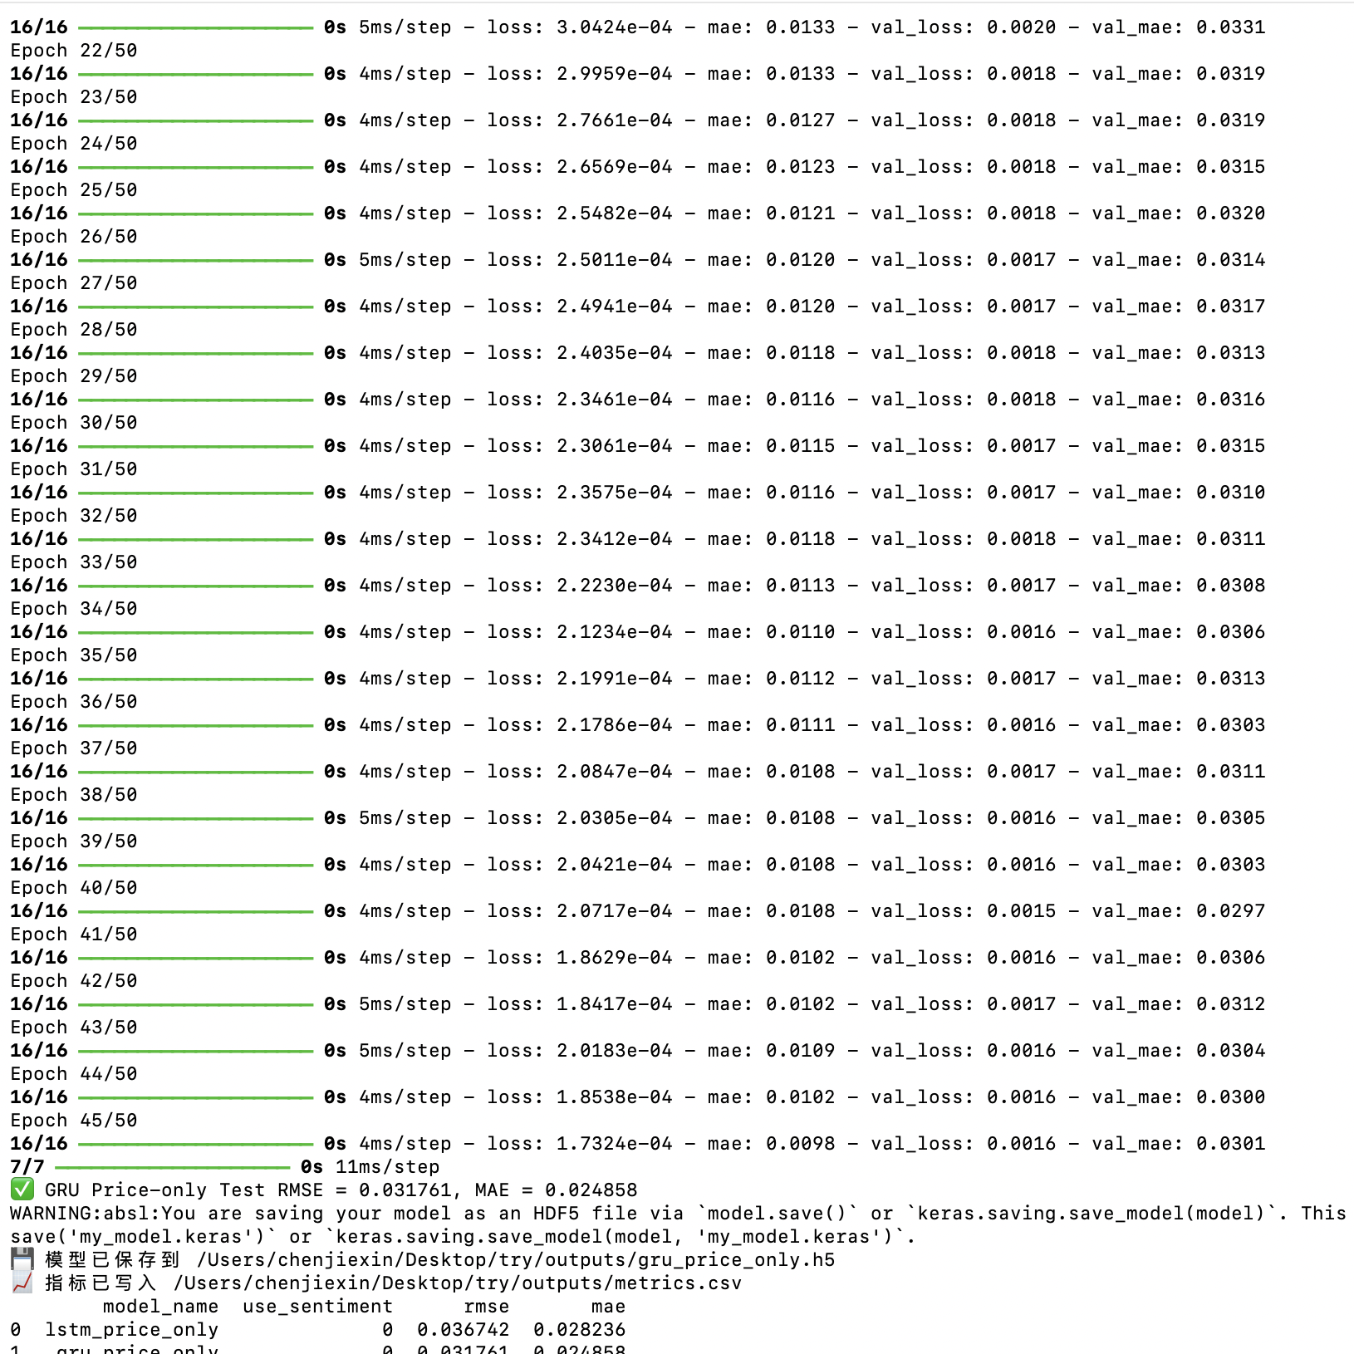

**03_att_cnn_lstm_price_only.py**

**Purpose:  
Train a hybrid model combining 1D CNN (local pattern extraction), LSTM (temporal dependency modeling), and an Attention layer (feature weighting).  
This architecture captures both short-term patterns and long-range dependencies using only stock price features.**

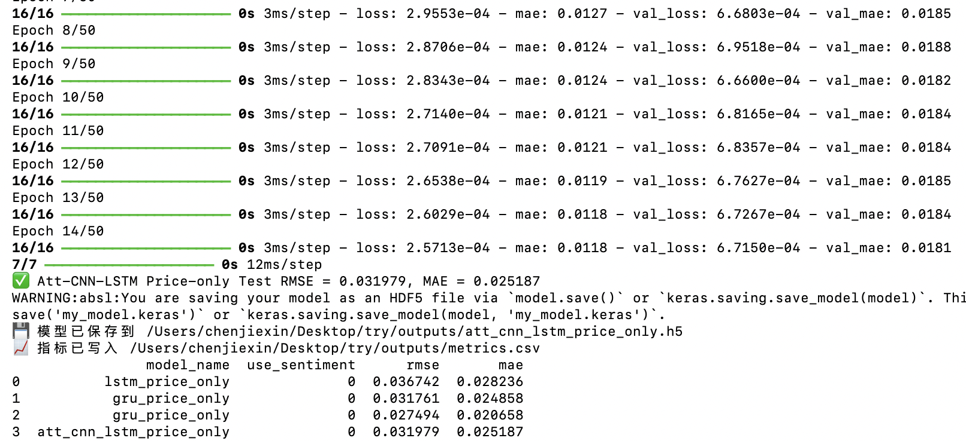

**📌 Deep Learning Models with Sentiment**

**These models test whether adding sentiment features from news articles improves prediction accuracy compared to price-only models.**

**04_lstm_with_sentiment.py**

**Purpose:  
Train an LSTM model using both price-based features and sentiment scores.  
This evaluates whether incorporating textual sentiment provides additional predictive power.**

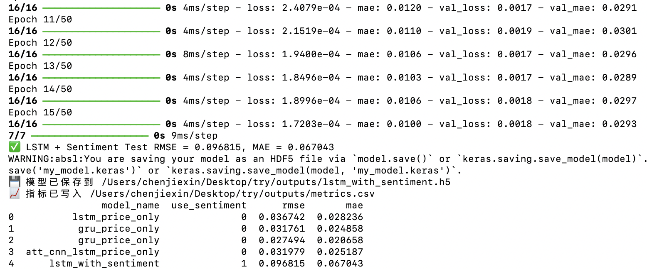

**05_gru_with_sentiment.py**

**Purpose:  
Train a GRU model enhanced with sentiment information.  
This allows comparison against both the price-only GRU and the LSTM sentiment model.**

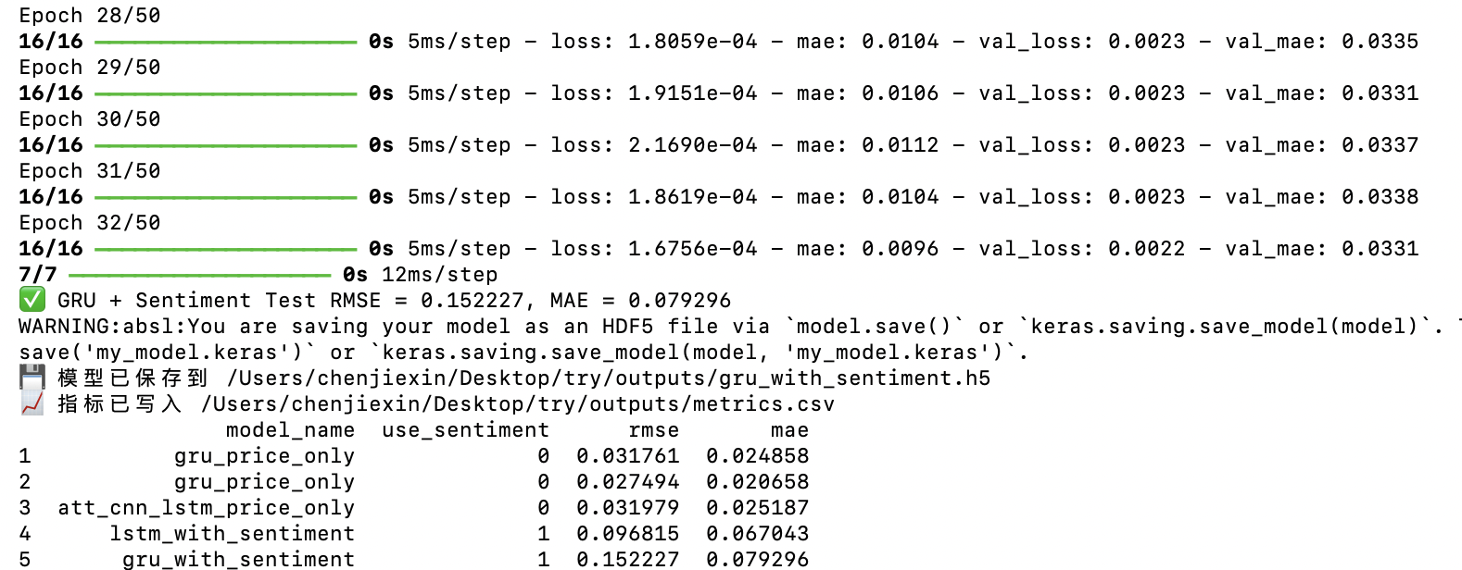

**06_att_cnn_lstm_with_sentiment.py**

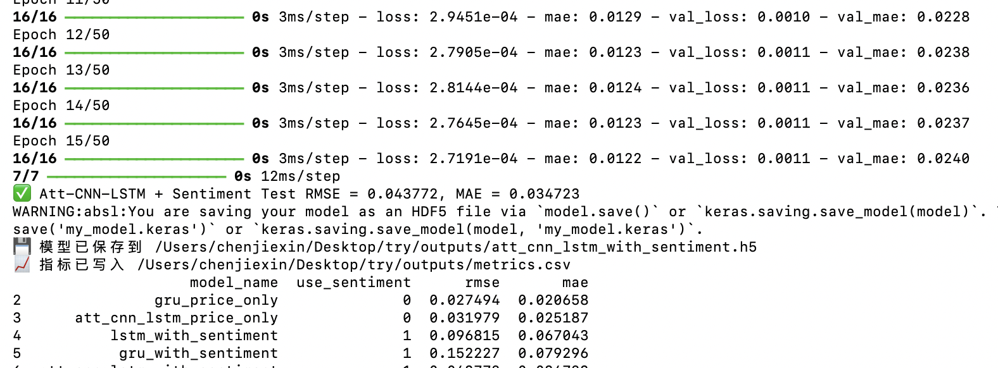

**Purpose:  
Train the full hybrid model (CNN + LSTM + Attention) augmented with sentiment features.  
This is the most expressive model in the pipeline and is designed to capture complex interactions between price movements and news sentiment.**

**5。Model comparsion：**

**✅ compare_models.py**

Purpose:  
Load all recorded model metrics from outputs/metrics.csv and perform a consolidated comparison across baselines, price-only deep learning models, and sentiment-enhanced models.  
This script ranks models by performance (e.g., RMSE, MAE), evaluates the effect of sentiment features, and generates a summary table used for reporting and visualization.

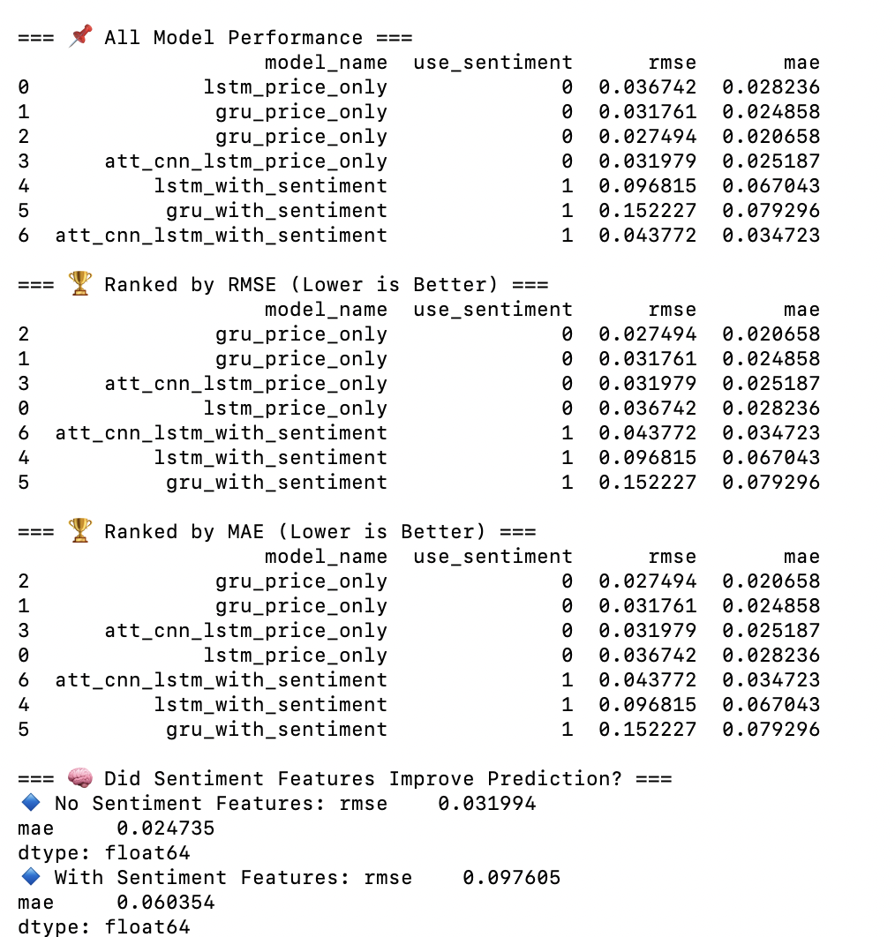

**✅ plot_results.py**

Purpose:  
Generate visualizations summarizing model performance, including bar charts, line plots, or grouped comparisons of RMSE/MAE across all models.  
These plots provide an intuitive view of how baselines, price-only models, and sentiment-augmented models differ, and highlight which architectures perform best.

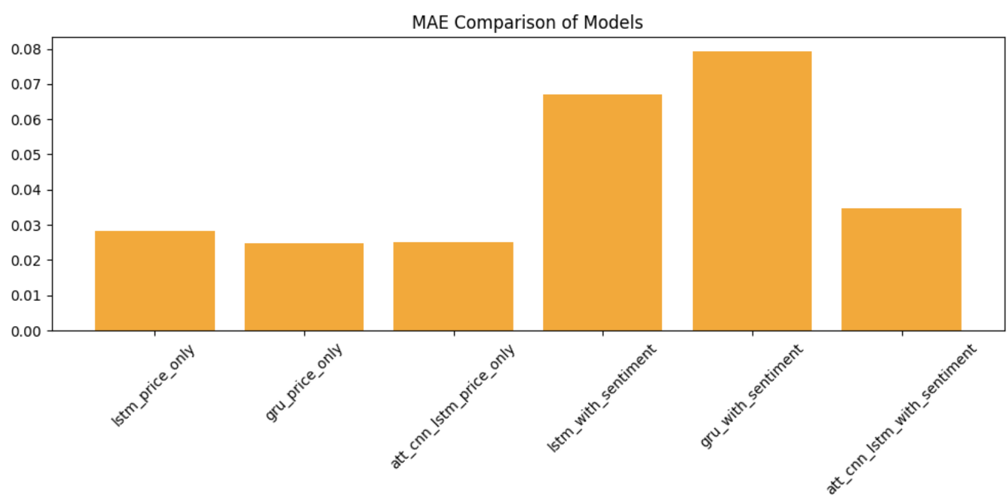

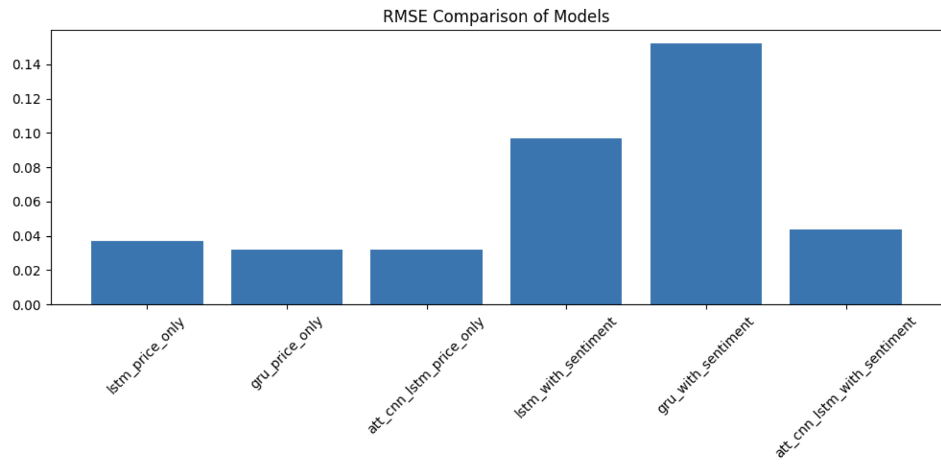

**At this point, your entire research workflow is complete locally.**

**⭐ 2. What Airflow Adds (Automation + Scheduling)(using the big data technology)**

This Airflow pipeline automates the entire workflow of the stock + news sentiment project.

**1. Data Ingestion**

Airflow first runs two tasks to download:

* Stock price data
* News data

**2. Data Cleaning**

Next, it cleans both datasets to ensure consistent formatting.

**3. Feature Engineering**

Airflow then generates:

* Sentiment features from news
* Technical indicators from stock prices

**4. Model Training (6 models)**

Airflow automatically runs six deep learning models:

* LSTM / GRU / CNN-Attention
* With and without sentiment features

**5. Evaluation & Visualization**

Finally, it:

* Compares all models
* Generates plots and metrics
* Saves results into the outputs folder

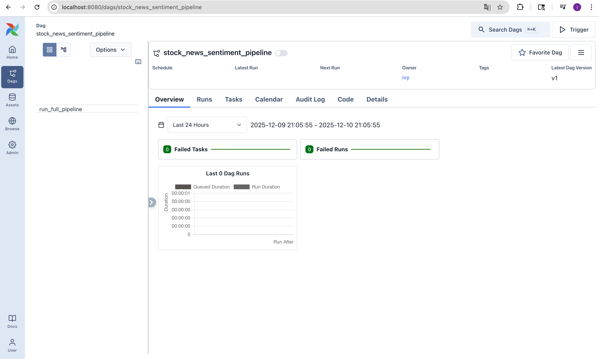

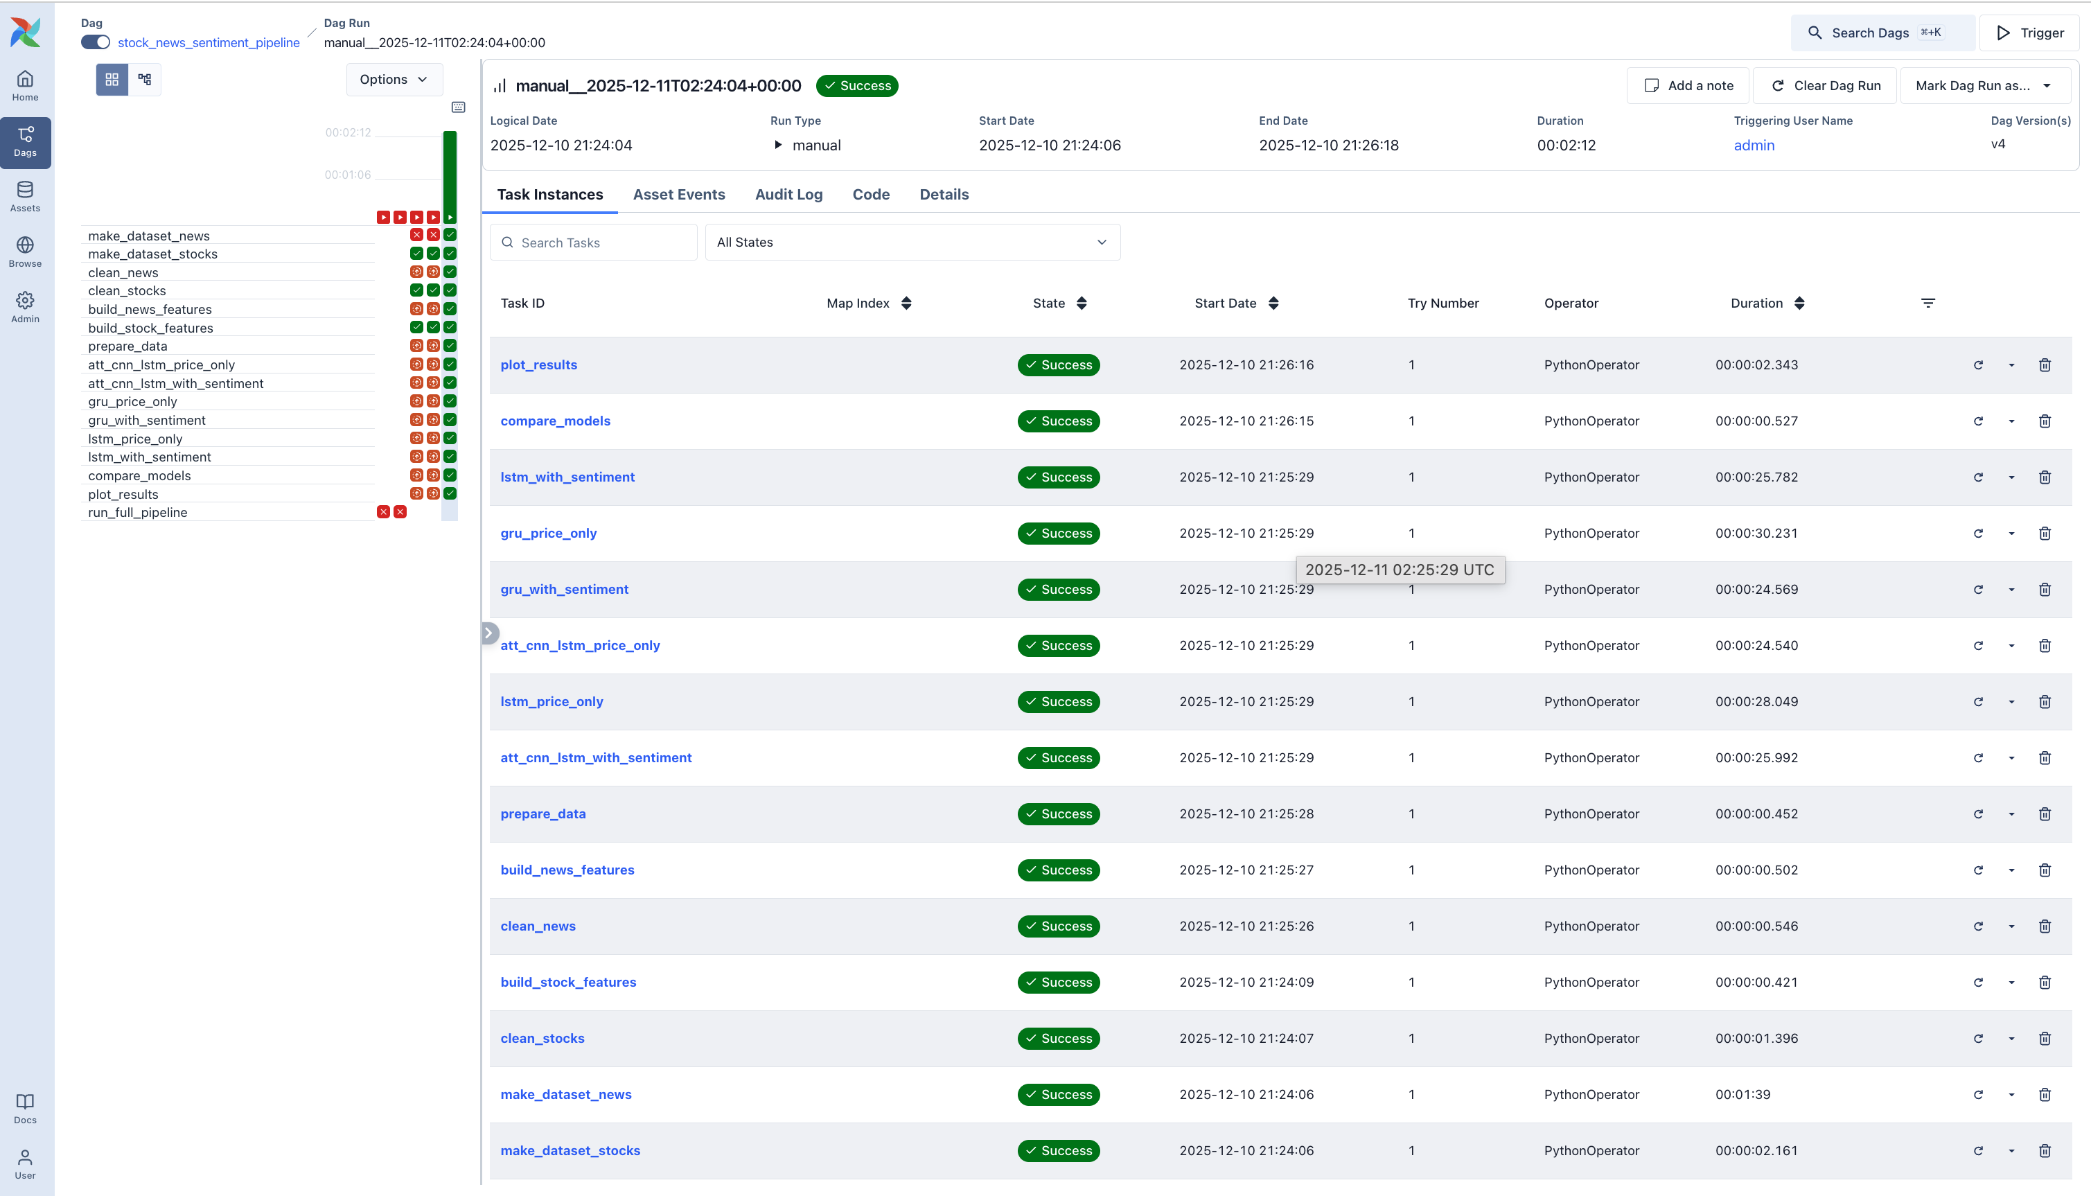

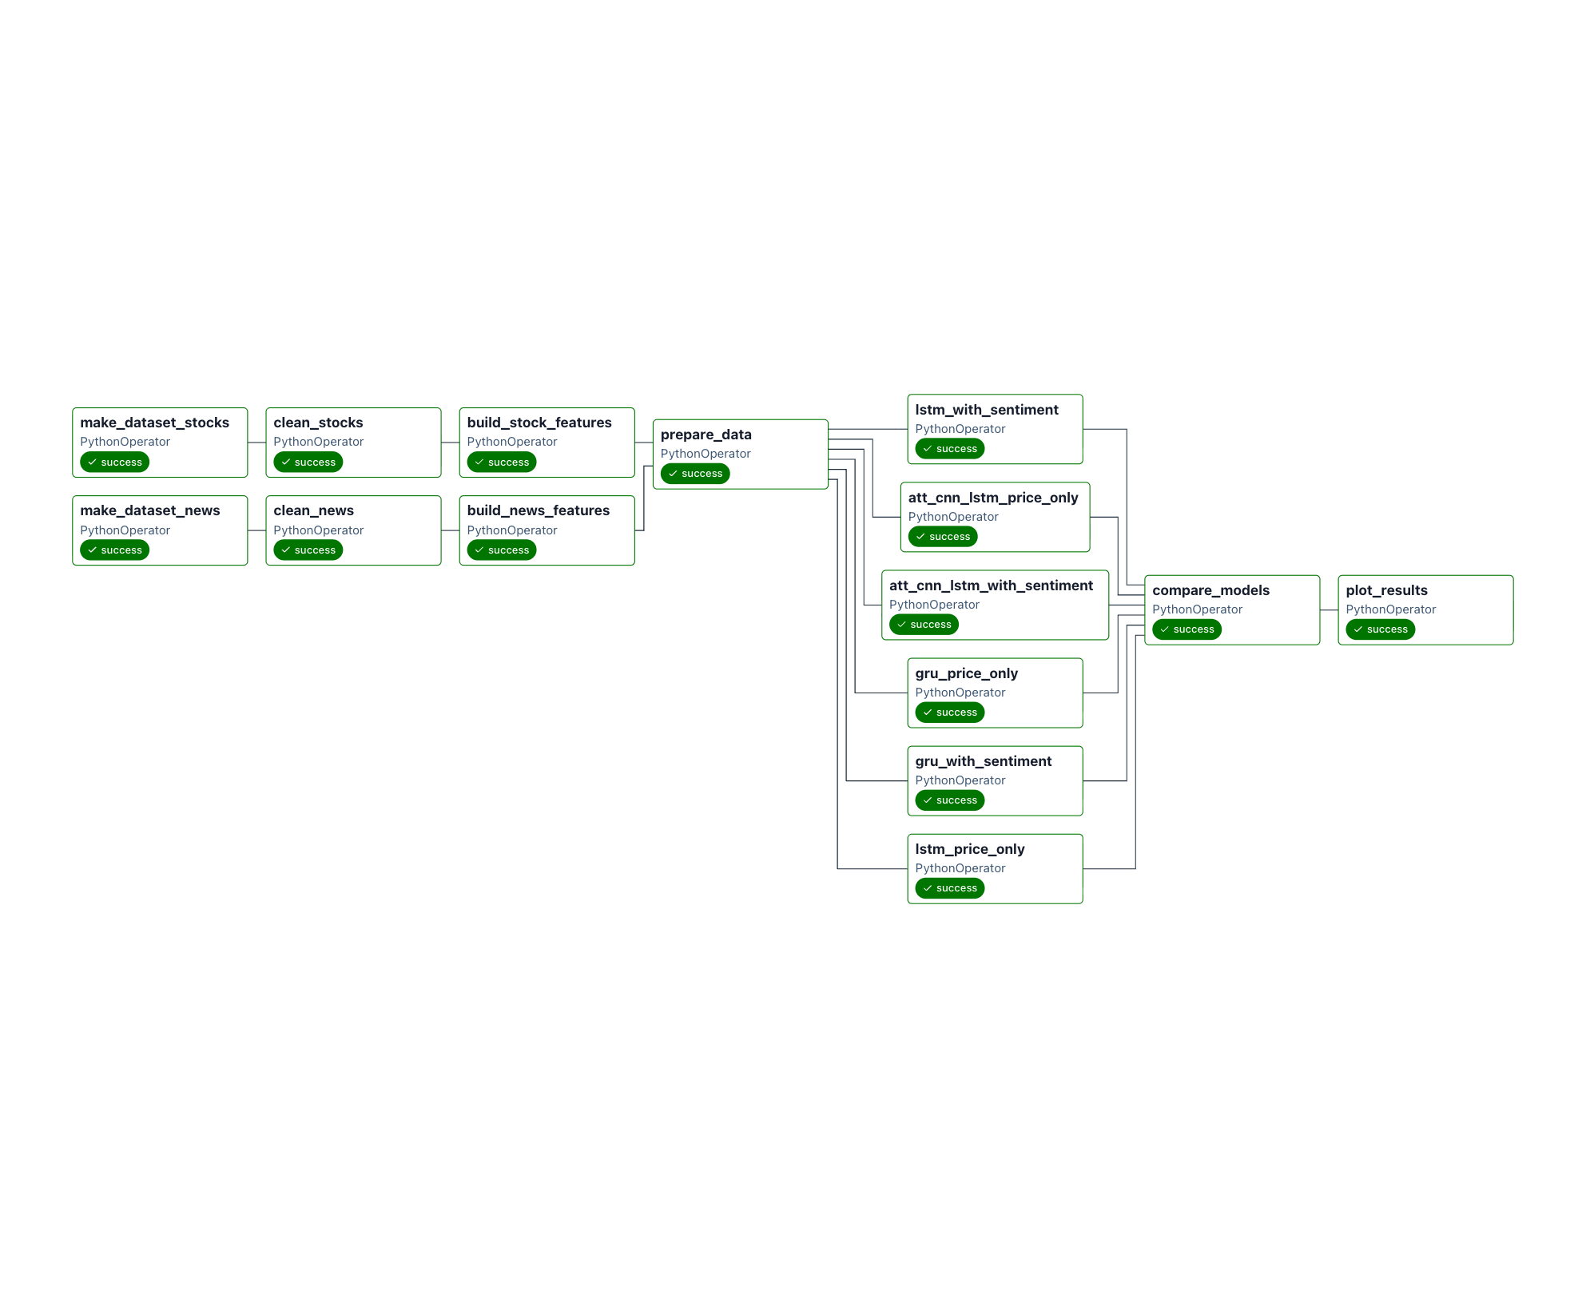

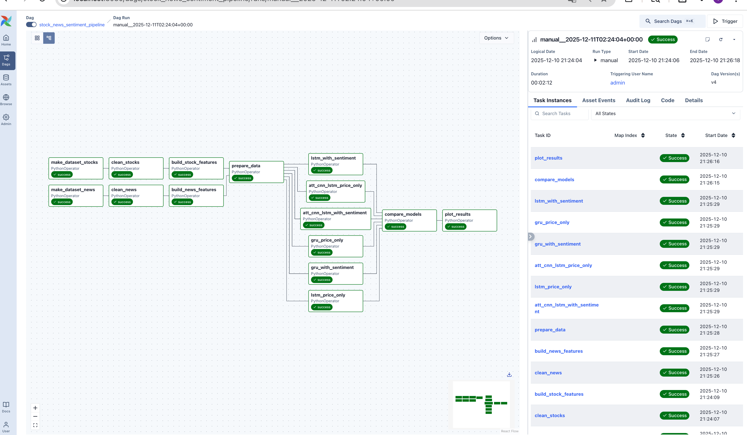

**⭐ 3. Integration With FastAPI + n8n (new tech!! If we have time!!!)**

**And interface**

Now comes the online part.

**FastAPI (online inference)**

* Loads the latest best_model.h5 when the server starts
* Exposes a /predict endpoint that returns predicted prices or trading signals

**n8n (automation / orchestration)**

* Runs every few minutes
* Fetches latest stock prices
* Calls FastAPI /predict
* Pushes BUY / HOLD / NO SIGNAL to Telegram

**Roles clearly separated:**

|  |  |
| --- | --- |
| **Component** | **Role** |
| **Airflow** | Offline ETL + feature engineering + model training + evaluation + update best_model |
| **FastAPI** | Real-time prediction server using the latest model |
| **n8n** | Automation workflow for fetching live data and distributing predictions |

Your final system looks like this:

Airflow → best_model.h5 → FastAPI (/predict) → n8n → Telegram signals